Computer Science 307: Software Engineering - Assignment 2: Designing, Building, and Testing a Software Feature
Elizaveta Skomorokhova
2 May 2026
Pomodoro Smash: Smart Study Session Planner
1. Feature Selection & Rationale
I chose the following user story from my backlog:
- Create Pomodoro Study Plan
As a user, I want to input my subjects and tasks so that I can receive a set of timers designed to help me complete my assignments.
- User can enter at least one subject.
- User inputs chapters, assignments and number of parts an assignment has.
- System generates 25 min study sessions and displays them by subject and assignment.
In its essence, The Pomodoro Smash is a simple timer app. This is the key feature that separates it from the competition. By creating a comprehensive hierarchical labelled structure of timers from the given list of assignments, Pomodoro Smash can replace a separate application for keeping a list of study-related tasks for students, thus combining to-do list functionality with timed focus sessions. Once this part of the project is completed, 80% of the work will be finished. This user story requires clear and minimalistic design to ensure adoption rates and will thus determine the aesthetic of the app. After this functionality is implemented, the app can already be sent to target users for feedback.
- Software Design Artifact
The web-app, with an interface designed for mobile use, will have three main files: index.html (structure), styles.css (sleek minimalistic visual design) and app.js which handles application logic. Here is the flow of the app.js file:
    - Sequence diagram
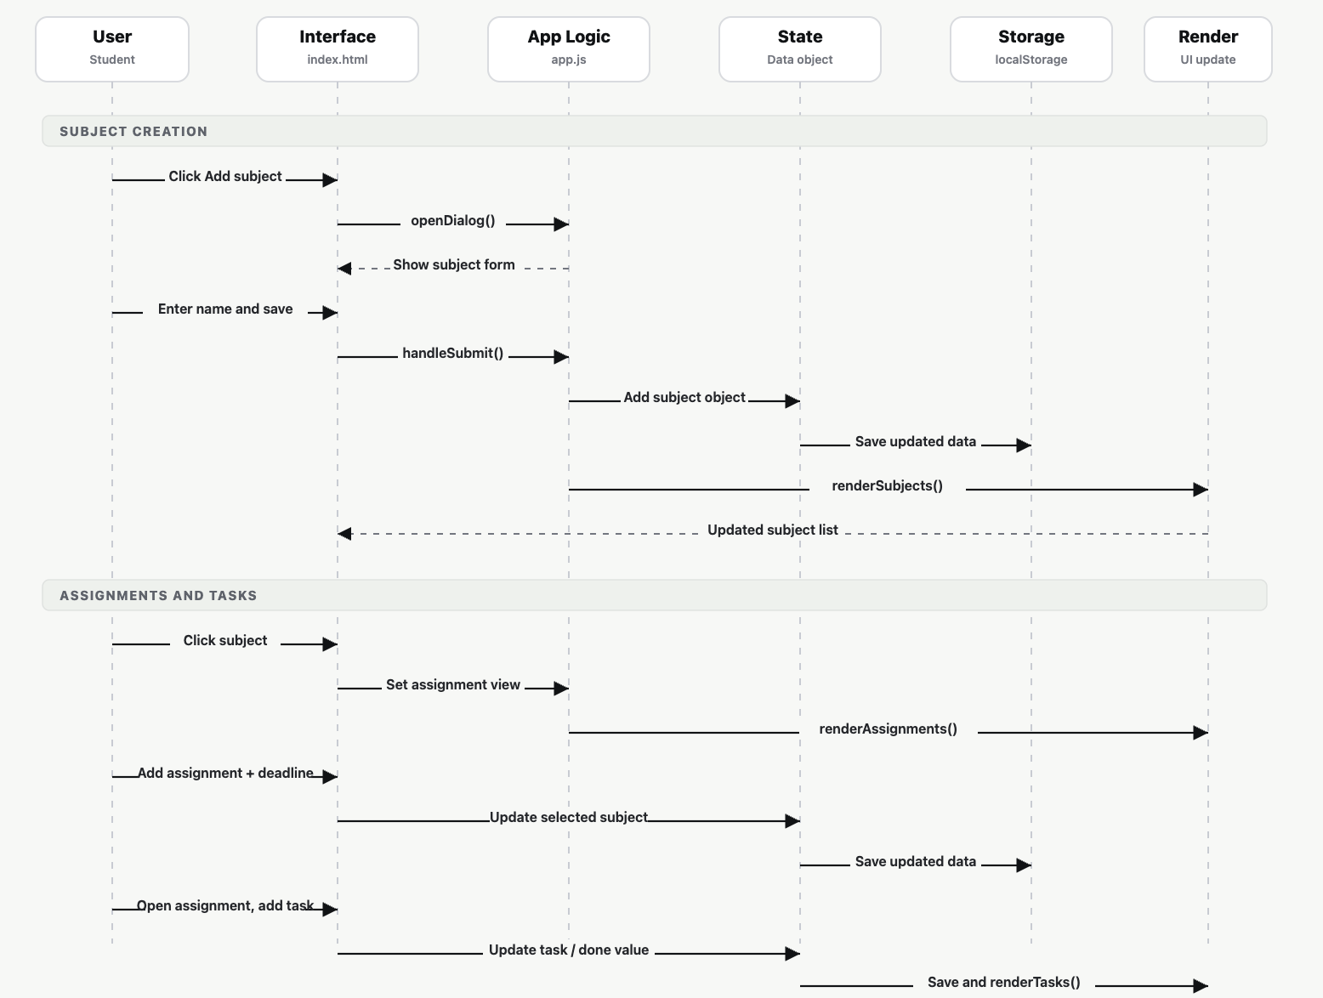
The User interacts with the Interface. The interface sends events to app.js, which updates the state object. After every change, app.js saves the state to localStorage and calls a render function. The render function updates the screen, and the user sees the latest subjects, assignments, or tasks.
The data flow starts when the user clicks the add button. The app opens a dialog with fields appropriate to the current view. After submission, the input is validated, added to the state object, saved to localStorage, and the screen is re-rendered. Clicking a subject moves the user into its assignment list. Clicking an assignment opens its task list. Clicking a task toggles its completion state. Rendering functions update the UI based on the current state.
The design supports usability by following a straightforward workflow and familiar folder structure: subjects contain assignments, and assignments contrain 25-minute tasks. The interface is designed for mobile use with large buttons and easy to navigate visuals. “Add subject/assignment/task” buttons guide the user towards the next action.
The design is reliable due to its simple state management system. The app stores user data in an object and saves it to LocalStorage after every change.
Maintainability is supported through simple app structure and separation into components: index.html, styles.css, app.js. The app.js file is organised through small reusable functions: renderSubjects, renderAssignments, renderTasks and saveData.
- Implementation
- 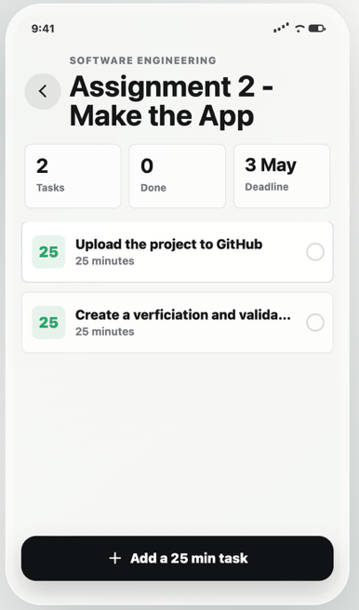
- Testing & Quality Evaluation
Test cases:
1) Add subject: Open app, click Add subject, enter a subject name, save
Subject appears in the subject list
2) Add assignment: Open a subject, click Add assignment, enter name and deadline, save Assignment
3) Add and complete task: Open assignment, add a 25-minute task, click task Task appears, toggles to completed

The core features work as intended. Users can Add subjects, assignments and 25-min tasks. The navigation works correctly. In terms of reliability, data persists after the page is refreshed, as the state is saved to localStorage. However, as data is only temporarily stored in the browser, once the user switches off the device, data is lost. The prototype works, but the finished application should have a consistent database file. In terms of input validation, assignments have a deadline parameter which cannot be set to a past date. In terms of usability, the application’s structure is easy to understand and has straightforward navigation. I would like to add a tomato to the design to stress its pomodoro nature. However, when the subject or assignment name is very long, it is not fully displayed on the screen, which needs to be fixed either by setting a restriction on the input length or by redesigning the way the app’s interface functions:
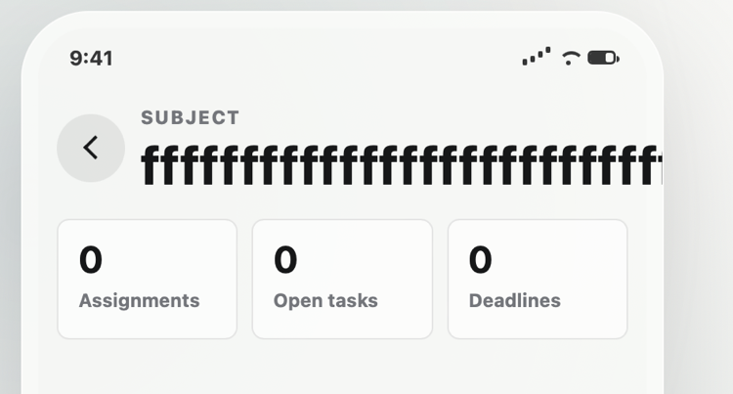
In terms of maintainability, the app’s current browser format is not the format wanted by the students; the app will have to be converted to an app store application. The code can also be separated into module files for better clarity and re-usability of components.

